Three-in-One Secure Destruction System｜YD-PZ Series

One-Stop Destruction Solution｜📘 Books + 💽 Hard Drives + 🧲 Magnetic Degaussing
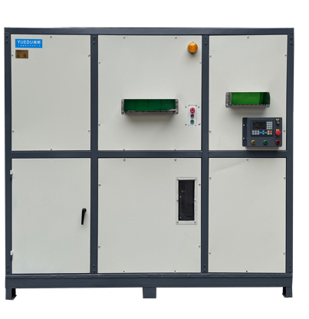 | 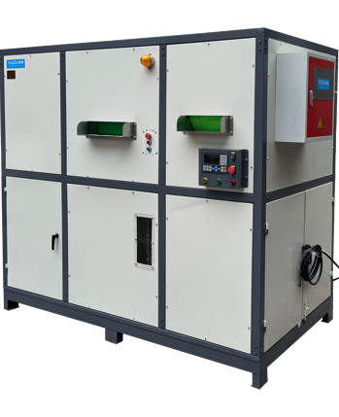 | 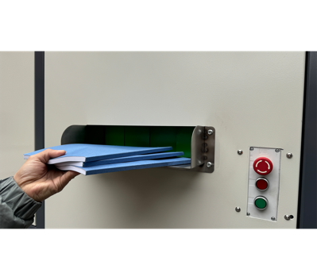 | 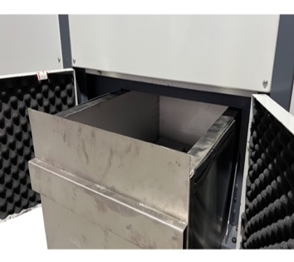
Front View | Right Side View | Safe Feeding Inlet | Fully Enclosed Waste Bin

🌍 20 Years of Engineering Excellence｜Innovative Customer-Centric Design & Proprietary Global Technology
The YD-PZ Series is the result of two decades of expertise in shredding and secure destruction. It is designed to meet the evolving needs of high-security document and media disposal.
✅ Key Features & Technical Advantages
●Meets top-tier confidentiality standards:  Shreds paper into 1mm micro-powder.  ●Handles extreme materials:  Capable of destroying ultra-thick and ultra-hard media, including hard drives, toner cartridges, and stainless steel components.  ●Compatible with low melting point materials:  Suitable for destroying modern storage media made with heat-sensitive new materials. | ●EHS-Compliant:  Fully aligned with global Environmental, Health, and Safety standards, trusted by multinational corporations.  ●Energy-efficient performance:  Reducing operational costs while maintaining performance.  ●Supports abrasive and composite materials: Specially designed to process glass fiber, mineral-based, and high-wear materials.

🔧 Technical Specifications:
Product Model | YD- PZ3020 | YD- PZ3025 | YD- PZ4025 | YD-PZ5030 | YD-PZ6030
Inlet Dimensions (mm) | 300*130 | 300*130 | 400*200 | 500*300 | 600*500
Shred Size | 1*2mm | 1*2mm | 1*2mm | 1*2mm | 1*2mm
Sheet Capacity | 80-130 | 100-150 | 150-200 | 200-300 | 300-500
Magnetic Field Strength | ≥12000Gs | ≥12000Gs | ≥12000Gs | ≥12000Gs | ≥12000Gs
Motor Power | 8.2KW, 380V | 11.5KW, 380V | 13.5kw, 380V | 19KW, 380V | 26.5KW, 380V
Dimensions (m) | 1.8*1.2*1.8m | 1.8*1.2*1.8m | 2*1.2*1.8m | 2.2*1.2*1.8m | 2.2*1.2*1.8m
Weight (kg) | 950KG | 1100KG | 1200KG | 1300KG | 1500KG
Pricing RMB | ¥198769 | ¥250000 | ¥299710 | ¥397595 | ¥499791
Pricing USD | $27,996 | $35,212 | $42,212 | $55,999 | $70,395
🌍 Preferred by Industry Leaders
Widely used across various sectors for secure information destruction, the YD-PZ Series has become the preferred choice of many Global Fortune 500 companies.


Machine Detail Views

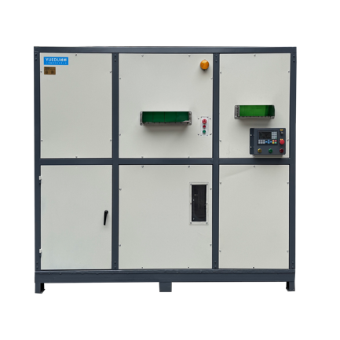 | 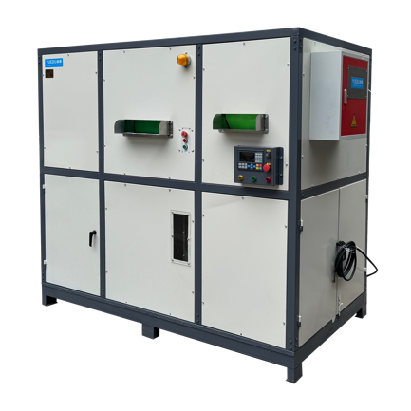 | 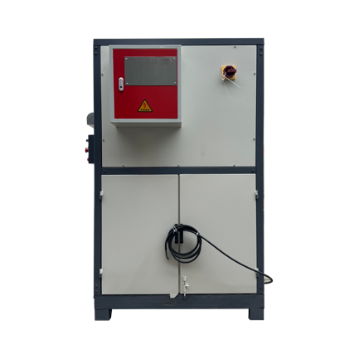
Front View | Right Side View | Center Side View
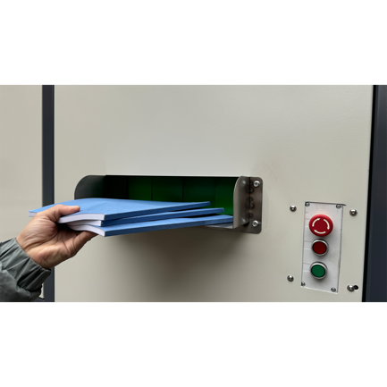 | 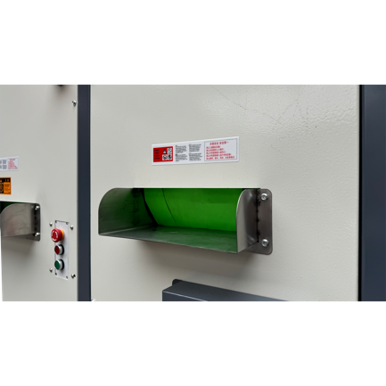 | 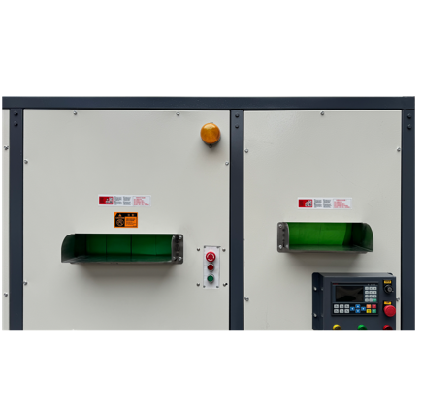
Feeding Port 1 | Feeding Port 2 | Safety Feeding Port
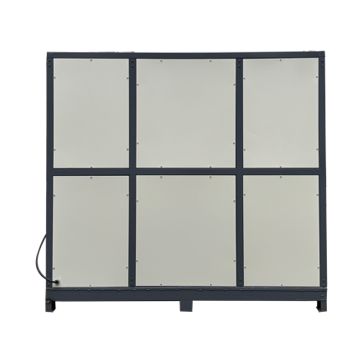 | 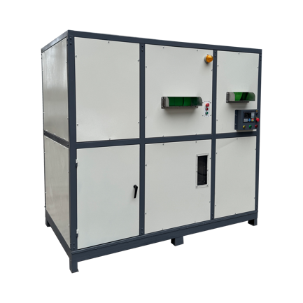 | 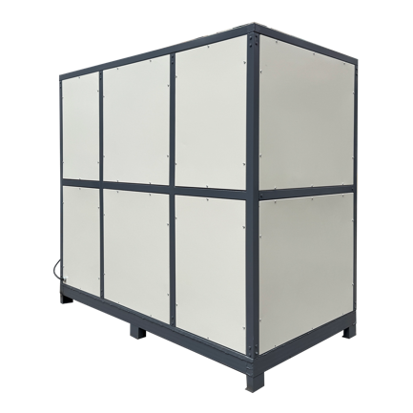
Rear View | Left Side View | Rear-Right View



Shredding Result – Storage Media

Toner Cartridges 🍭 | Hard Drives🍭 | Electronic Storage Media🍭
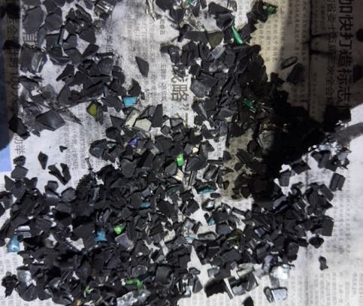 | 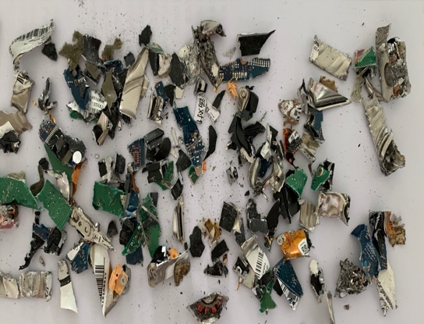 | 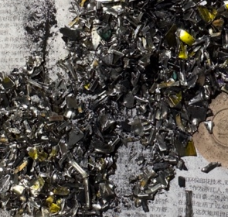
🍭Shred size will be based on the specification mutually confirmed upon ordering.

Shredding Effect (1*2mm)

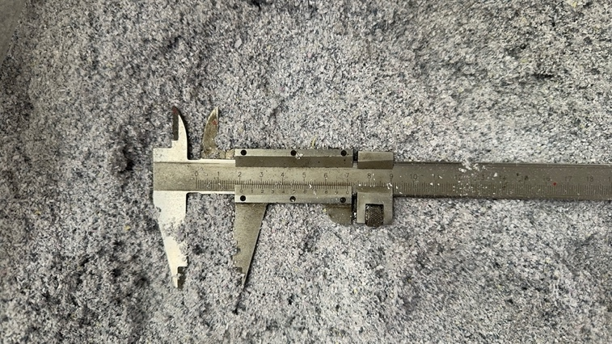 | 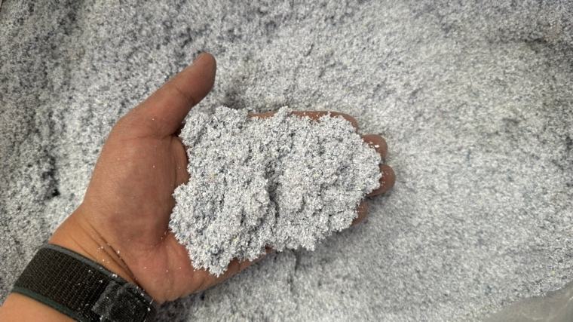

Customer Cases
Case Z
Case X
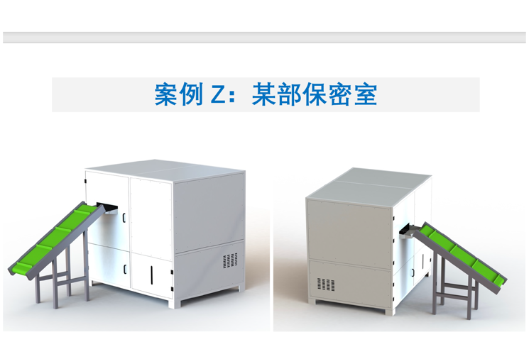 | 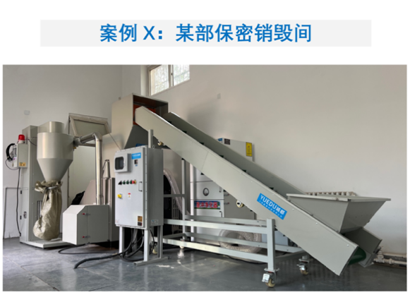

Customizable Sizes: Available in 1mm, 3mm, and 5mm specifications. For additional options, please contact customer service.
For Long-Term Operation: Feed materials evenly and wait until the materials in the shredding chamber are fully processed before adding more. For continuous feeding, ensure each batch is no more than one-third of the value specified in the table.

